SESI MONAGATANE
ST-10468899
PROGRAMMING 6212
PART 1

SECTION A

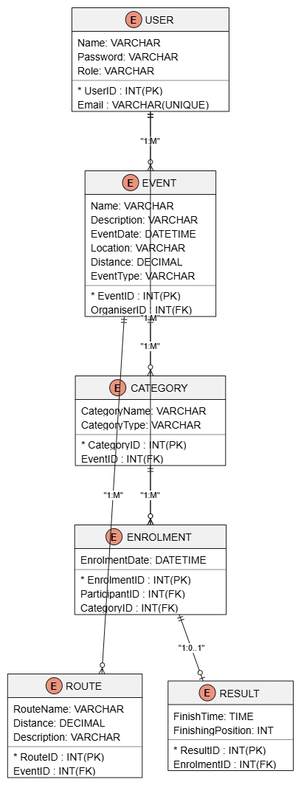
SECTION B

The RaceDay API endpoint plan defines the HTTP methods, routes, access roles, request information and expected responses required to support the functional requirements of the system. The endpoints provide functionality for authentication, user profiles, event management, category management, event enrolments and participant results. Role-based access is used to ensure that Organisers and Participants can only perform actions appropriate to their roles.

Authentication

HTTP method | Route | Description | Role required | Request body | Expected  Response
POST | /api/auth/register | Registers a new RaceDay user as a Participant or Organiser. | None | Name, Email, Password, Role | 201-User created successfully
POST | /api/auth/login | Authenticates a user and provides access according to their role. | None | Email, password | 400-Login successful  401-Unauthorized-  Invalid credentials

User Profile
HTTP method | Route | Description | Role required | Request body | Expected response
GET | /api/users/profile | Allows a logged-in user to view their own profile. | Participant / Organiser | None | 200 -Profile details returned
POST | /api/users/profile | Allows a logged-in user to update their own profile. | Participant / Organiser | Name, Email | 200-Profile updated successfully

EVENTS
HTTP method | Route | Description | Role required | Request body | Expected response
GET | /api/events | Retrieves a list of upcoming events | Participant /organiser | None | 200-List of events returned
GET | /api/events/{id} | Retrieves details of a specific event | Participant/organiser | none | 200-Event details returned
POST | /api/events | Creates a new event | organiser | Name, Description, Date, Location, Distance, EventType | 201-Event created successfully
PUT | /api/events/{id} | Updates an existing event | organiser | Name, Description, Date, Location, Distance, EventType | 200-Event updated successfully
DELETE | /api/events/{id} | Deletes an existing event | organiser | None | 200-Event deleted successfully

EVENT ENROLMENTS
HTTP method | Route | description | Role required | Request body | Expected response
POST | /api/events/{eventId}/enrolments | Allows a participant to enter an event and select a category | Participant | category | 201-Enrolment created successfully
GET | /api/events/{eventId}/enrolments | Allows an organiser to view participants enrolled in their event | organiser | None | 200-List of enrolments returned
GET | /api/users/profile/enrolments | Allows a participant to view their own event enrolments | participant | None | 200-Participant’s enrolments returned

RESULTS
HTTP method | Route | Description | Role required | Request body | Expected response
POST | /api/events/{eventId}/results | Records a participant’s finish time and finishing position | organiser | ParticipantID, FinishTime, FinishingPosition | 201-Result recorded successfully
GET | /api/events/{eventId}/results | Allows an organiser to view results for their event. | organiser | None | 200-Event results returned
GET | /api/users/profile/results | Allows a participant to view their own results and performance history. | Participant | none | 200-Participant results retuned

SECTION C

